WPR 281 : ASSIGNMENT 1

Name : Hrudhay Reddy Garisa

Student no: 577833

Table of Contents

Create a repository 2

Create a Branch 3

Opening a Pull request 7

Merging the Pull request 9

# Create a repository.

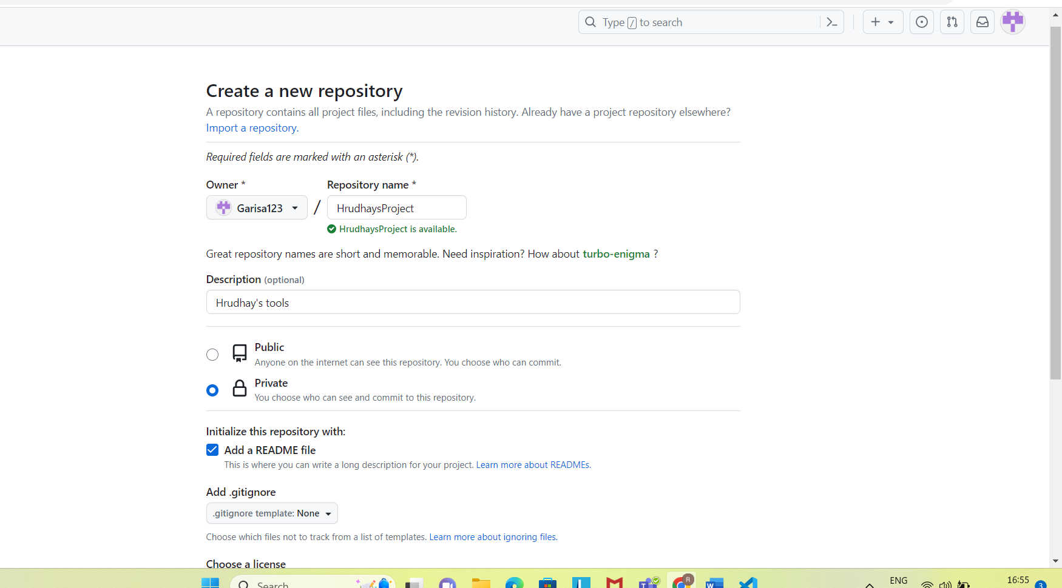

# Create a Branch

Making and Committing changes

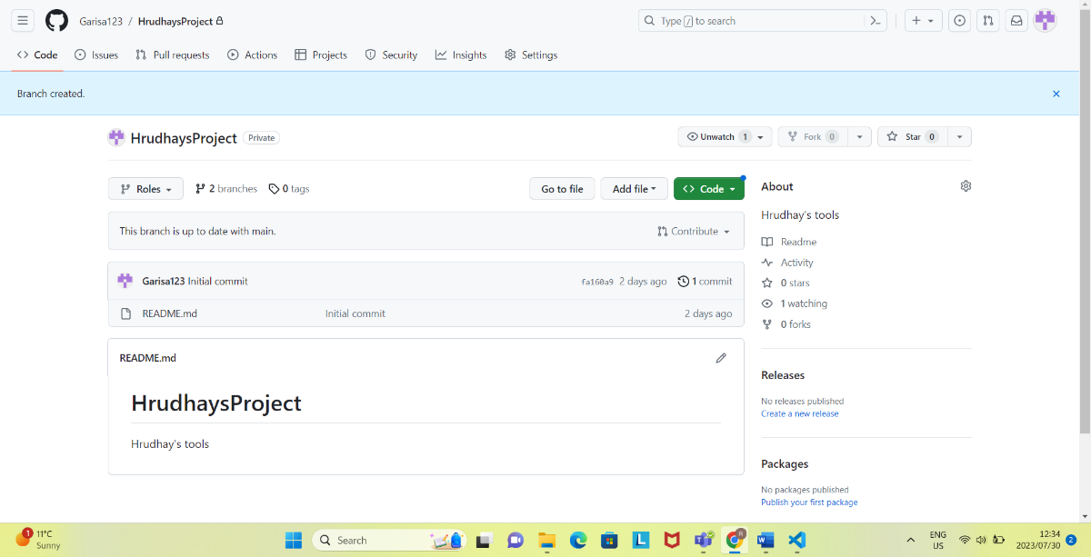

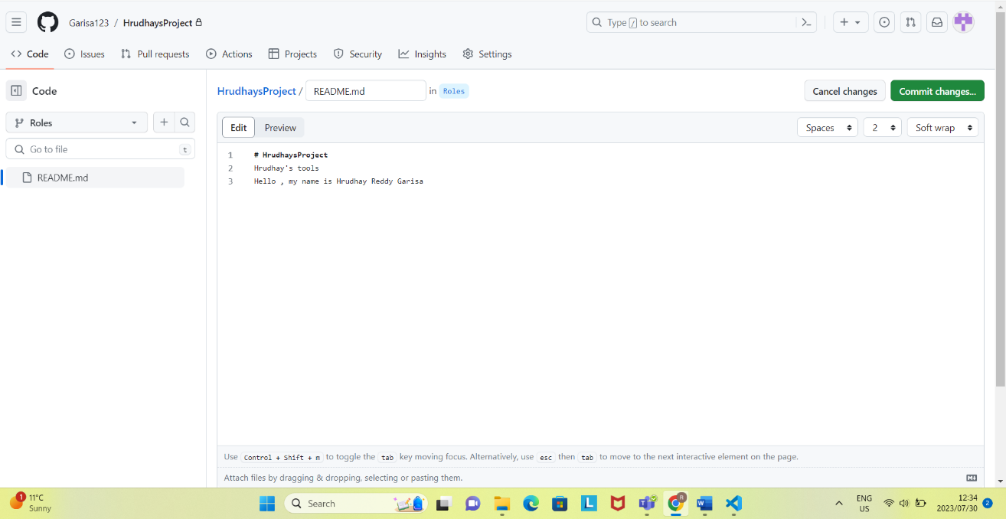

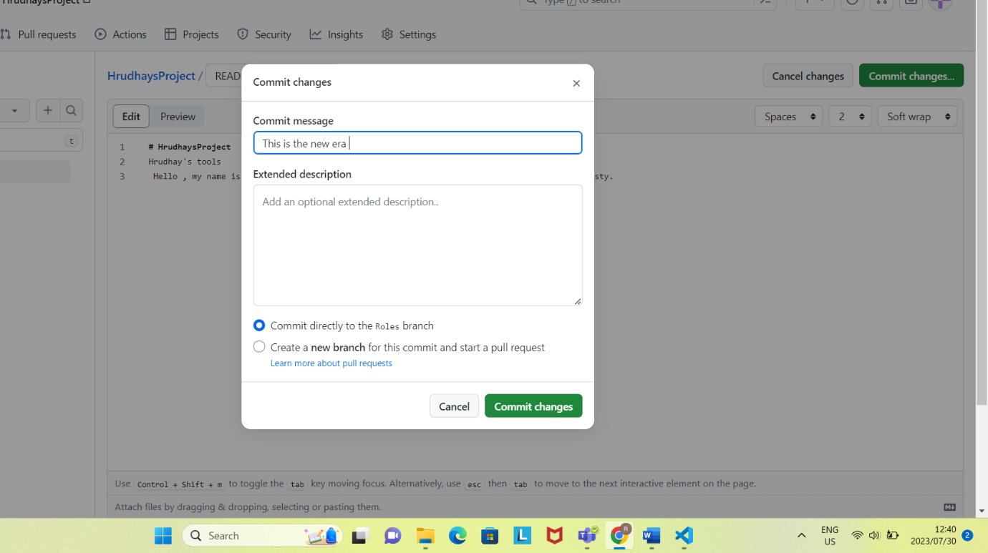

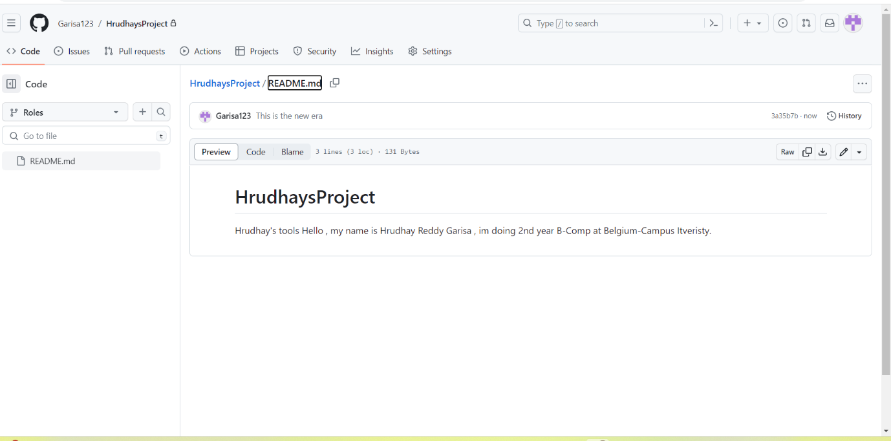

# Opening a Pull request

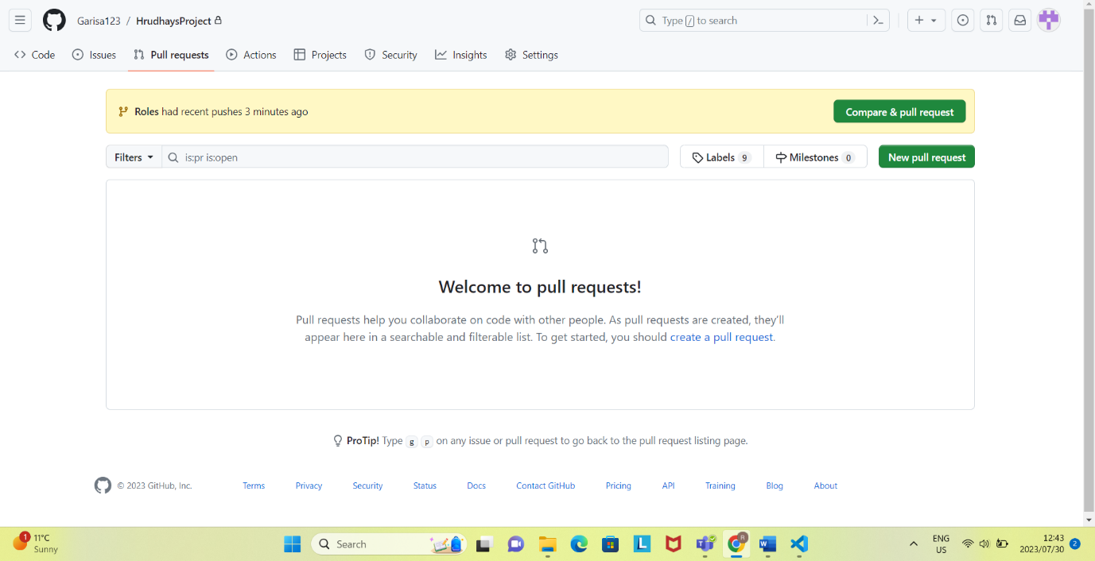

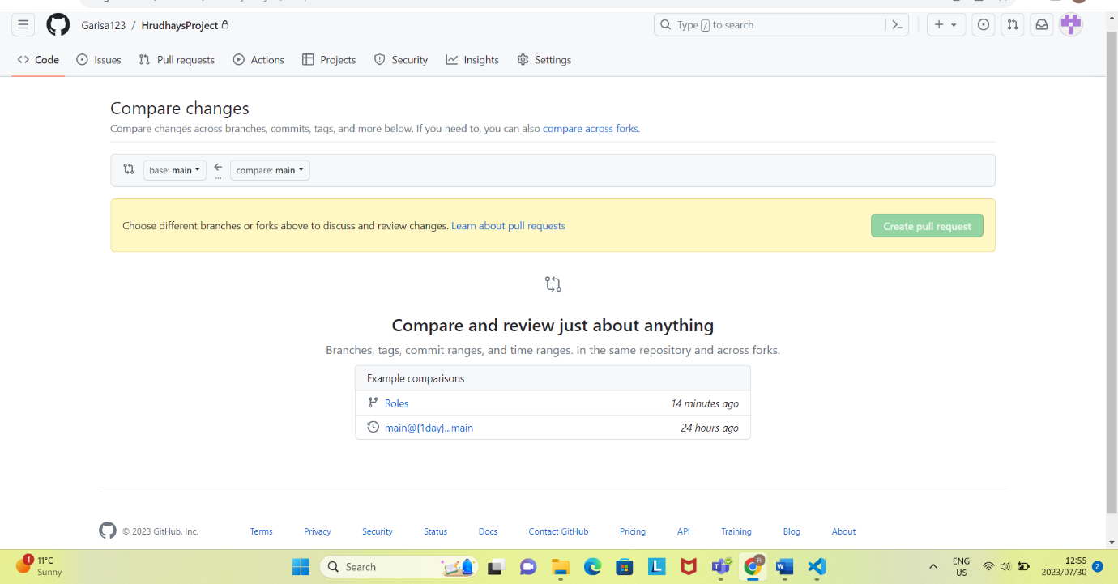

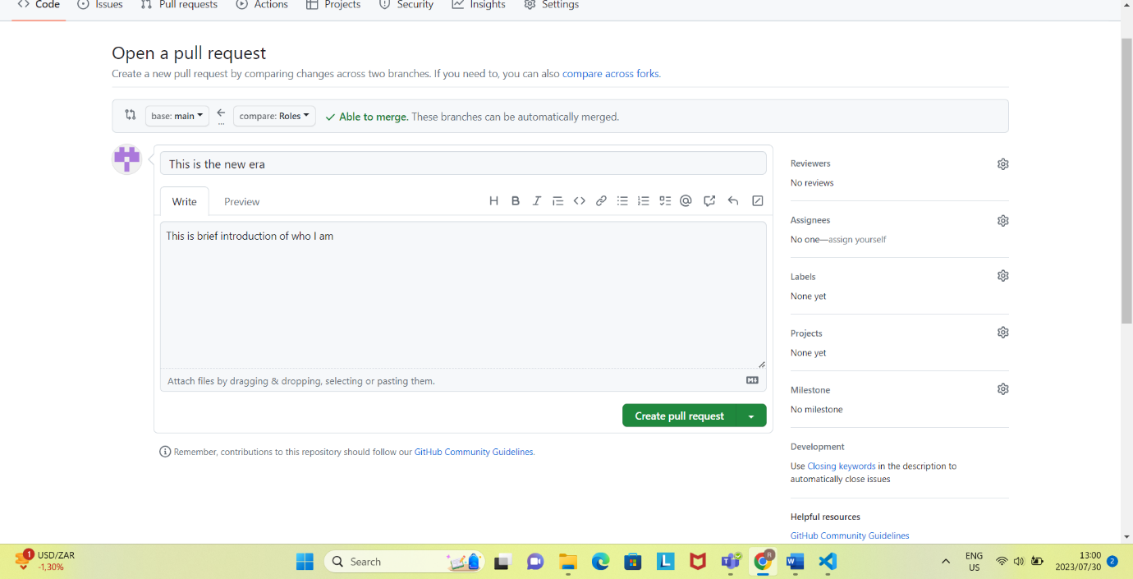

# Merging the Pull request

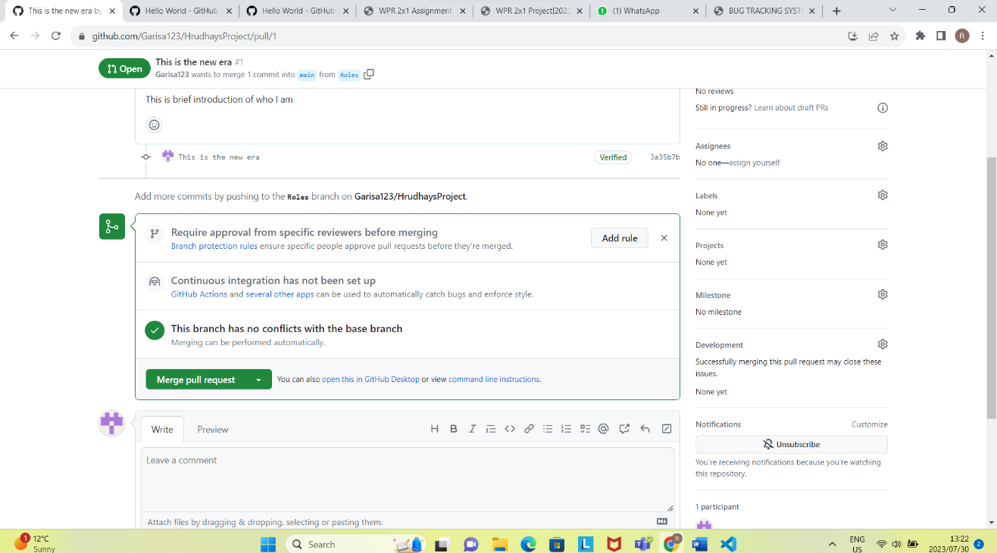

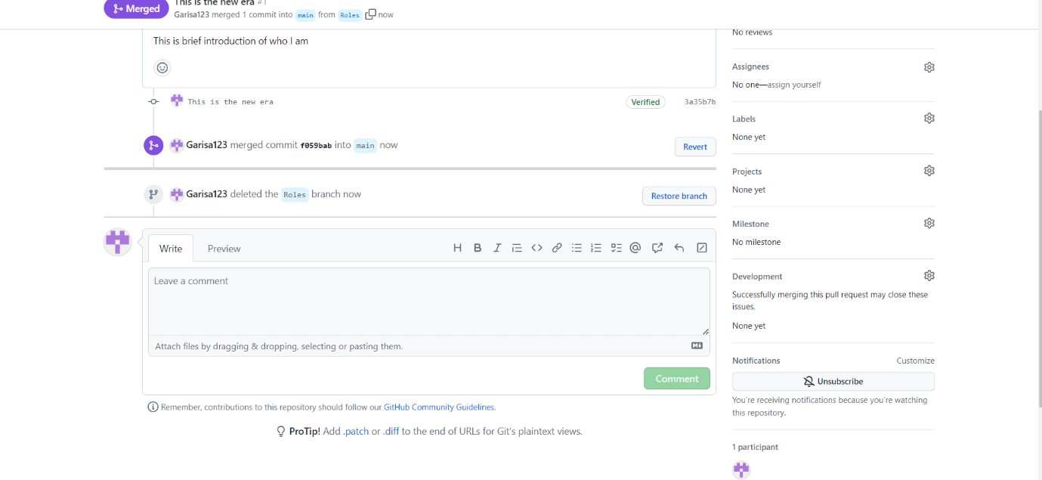

# Link to full path of your repository

https://github.com/Garisa123/HrudhaysProject

https://github.com/Garisa123/HrudhaysProject